INSTALLATION OF GIE MAIN GATE & SECURITY SYSTEM

Guyana Shore Base Inc. hereby invites interested companies to submit proposals for the Installation of GIE Main Gate & Security System.

Scope of Work
- Establish a single security entry point at #1.
- Provide a flatpack for security ranks at #1 and single huts at #3 and #4.
- Installation of a sliding gate before barriers (yellow broken lines).
- Install entry and exit electronic security barriers at #1 along with an electronic pedestrian turnstile and card reader.
- Installation a single electronic barrier at #4 and #3 to ensure areas are controlled and that there is no unauthorized access to each. This should include linkage to the pedestrian walkway with card reader.
NB: SITE VISIT MUST BE CONDUCTED TO PROVIDE QUOTE.
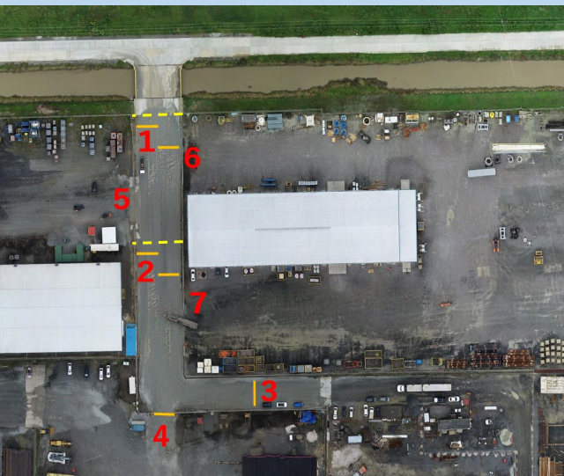

Instructions to Bidders
- Proposals are to be submitted along Valid Business Registration or equivalent, Valid GRA & NIS Compliance, Local Content Certificate.

- Proposal and documents must be submitted to the e-mail address below on or
before 15th February 2024.

Release Date: February 2nd 2024

