REQUEST FOR PROPOSAL

Design, Fabrication and Installation of Cable tray system at the Guyana Shore Base Industrial Estate (ANNEX).

Guyana Shore Base Inc. hereby invites interested suppliers to submit Proposals to participate in the tendering process for the Design, Fabrication, and Installation of Cable tray system at the Guyana Shore Base Industrial Estate (ANNEX).

Description of Works
General: Provision of Engineering service for the Design, Fabrication, and Installation of Cable tray system at the Guyana Shore Base Industrial Estate (ANNEX).

Requirements.
- Design and Fabrication and Installation of 432 meter, 18 inches wide cable tray shown in Figure 1.
- Cable tray to be installed over the drain running along northern fence of plots 1 to 4 and Drain bordering Plots 1 and 2 as represented by blue lines in Figure 2 below.
- All materials, equipment and manpower are to be supplied by the contractor.
- Daily housekeeping and proper disposal of waste materials during installation and at the end of the project.
- Strick Adherence to GYSBI’s guidelines and policies during operation on site.

Specification
- Material used shall be steel.
- Trays shall be coated with red oxide primer to a minimum DFT of 80 µm.
- Minimum Load Bearing Capacity of 175lb per meter.
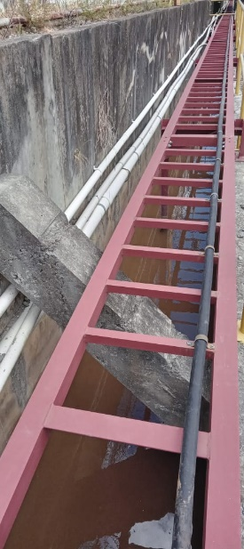
Figure 1.

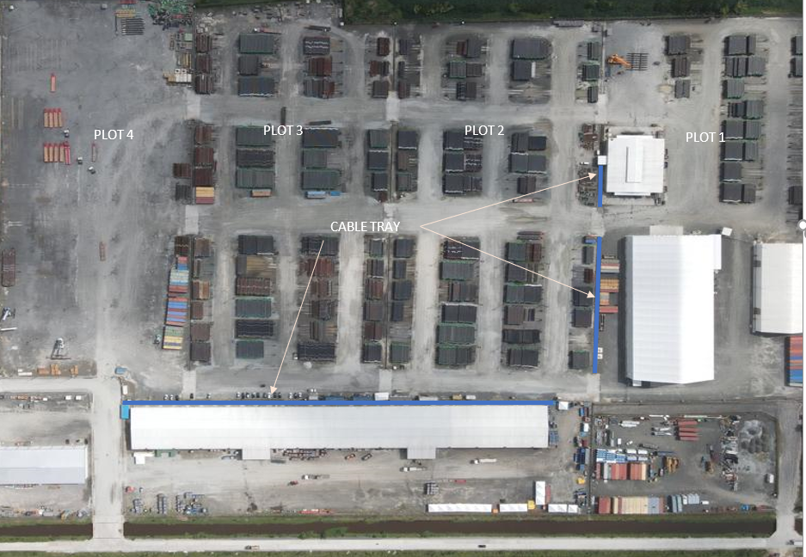

Figure 2: Sketch of GYSBI Annex showing location of cable trays.

Interested bidders are to submit the following to the e-mail address below:

- COMPANY REGISTRATION
Company Acts Certificate/Business Registration or equivalent, GRA & NIS Compliance.

- LOCAL CONTENT CERTIFICATE
Company can submit proof of initiation of process.

BIDDER INSTRUCTIONS
- Submit relevant experience as a vendor e.g. past contract.
- All line items in cost proposal must be priced.
- Proposal must clearly show unit cost and total cost.
- All applicable VAT must be clearly shown.

Please submit proposals to e-mail: tenders@gysbi.com

