Request for proposal
Chain Link Fencing at Annex Plot 7

Guyana Shore Base Inc. hereby invites interested companies to submit proposals for Chain Link Fencing at Annex Plot 7.

Scope of Works

Approximately 350 linear feet of chain link fence (without gate) to be installed. Fabric and tie wire will be 9 gauge. Posts, fabric, and fittings including tension bars, brace bands, post caps and tie wire shall be hot dip galvanized. Tension wire shall be installed 100mm up from bottom of fabric and 100mm down from top of fabric. Tension bar will be secured to post with tension bands and carriage bolts. Welding of the fabric to the post is not an approved method of installation. Maximum deflection shall be 50mm when 22.5kg pull is exerted perpendicular to the center of the panel. Bottom of fence fabric shall be no more than 50mm from grade.

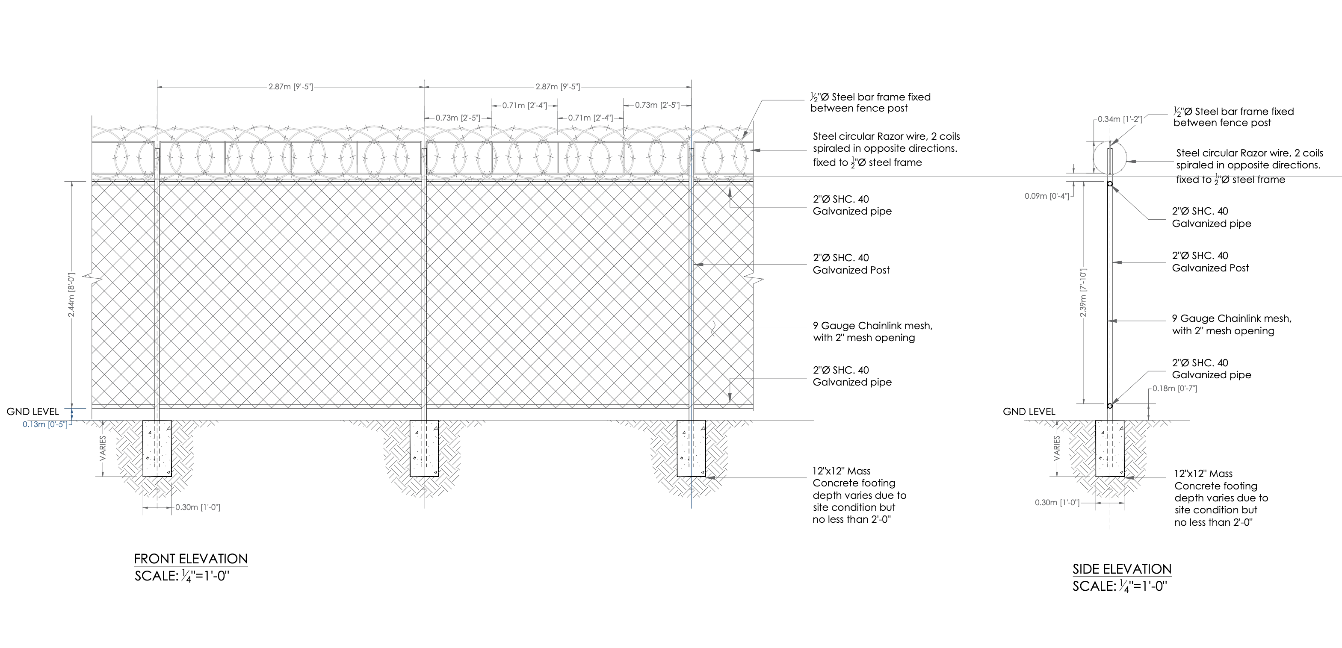
Figure 1: Type fence drawing

Figure 2: Sketch of GYSBI Annex

Instructions to Bidders

- Proposals are to be submitted along Valid Business Registration or equivalent, Valid GRA & NIS Compliance, Local Content Certificate.
- Proposal and documents must be submitted to the e-mail address below on or before March 2nd, 2023.

Email: tenders@gysbi.com

