Request for Quotation
Demolition & Removal of a Concrete Pad

Guyana Shore Base Inc. hereby invites interested bidders to submit quotations for the Demolition & Removal of a Concrete Pad as per the specifications below:

Item | Service Requirement | Preferred Equipment to Complete Job
1 | Removal of Trinidad Pad - Demolish and removal of 60’x90’x18” reinforced concrete pad and sand fill excavation area. | Track hoe with hydraulic hammer - A breaker is a powerful percussion hammer fitted to an excavator for demolishing hard (rock or concrete) structures. It is powered by an auxiliary hydraulic system from the excavator, which is fitted with a foot-operated valve for this purpose. Additionally, demolition crews employ the hoe ram for jobs too large for jackhammering or areas where blasting is not possible due to safety or environmental issues. Reference image below.

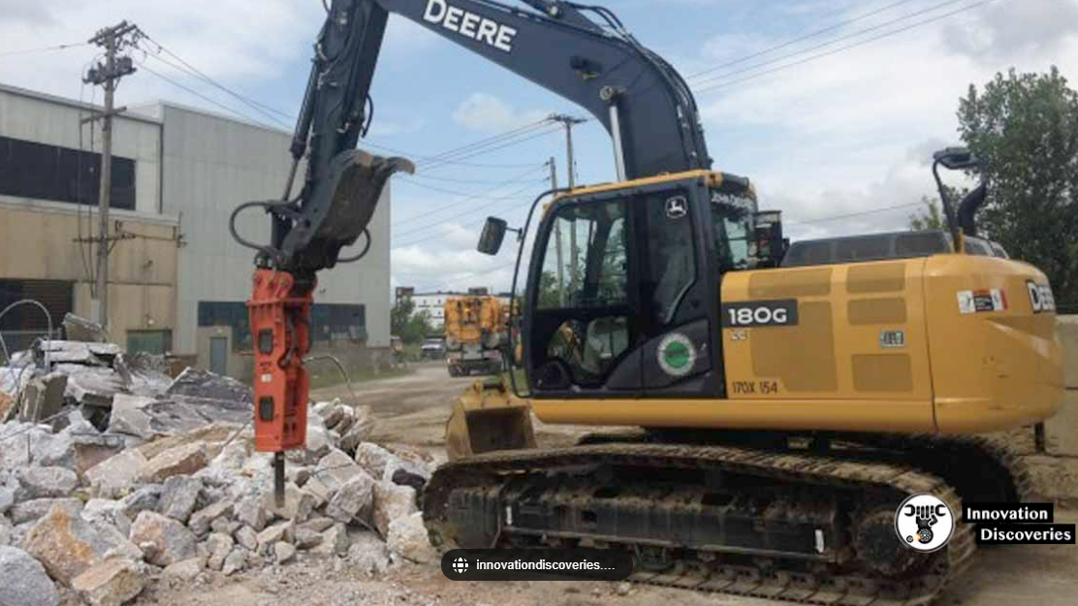

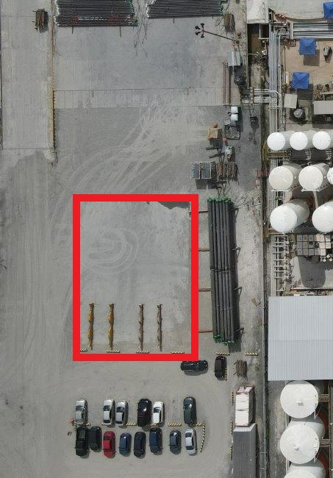

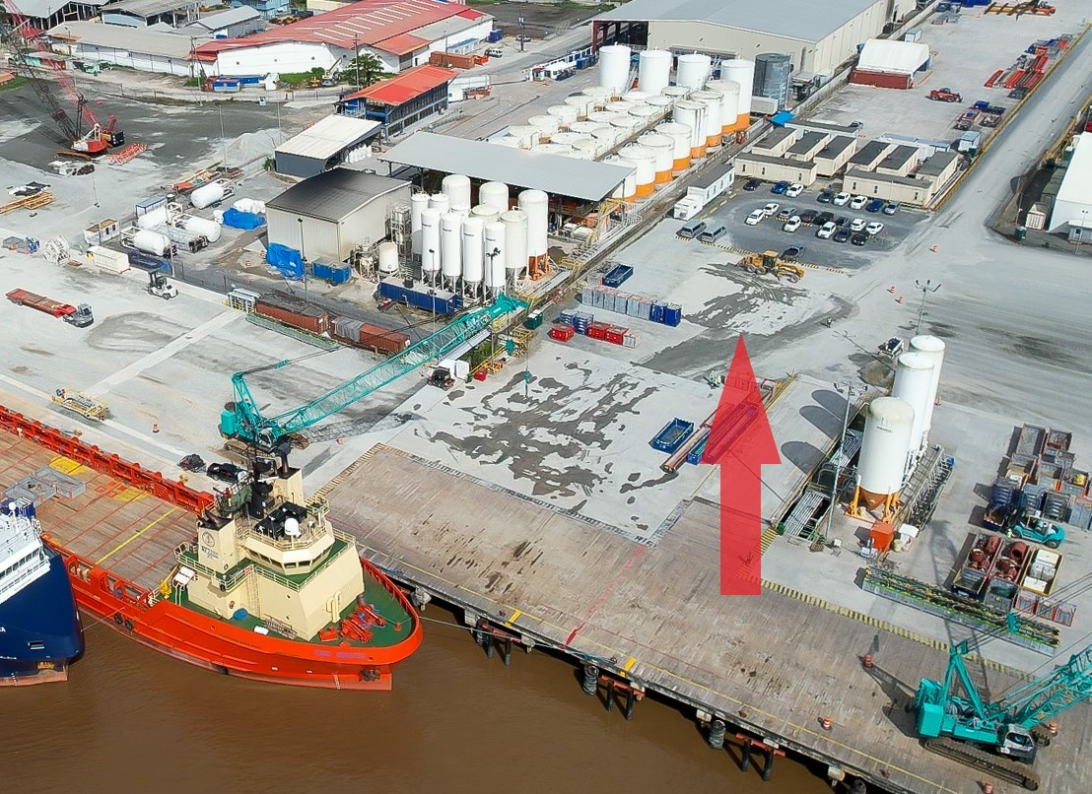

Interested bidders are to submit their quotations and the following information to the e-mail address below on or before February 7th, 2023.

- COMPANY DETAILS
Valid Business Registration or equivalent, Valid GRA & NIS Compliance.

- CONTACT DETAILS
Name, designation, email, phone number.

- CERTIFICATIONS
Local Content Certificate or proof that process has been initiated.

NB: Alternative demolition options can be submitted. Include equipment, manpower and schedule for any alternative methods.

E-mail: tenders@gysbi.com

