Request for proposal
Engineering design of light pole foundation

Guyana Shore Base Inc. hereby invites interested companies to submit proposals for Engineering Design of Light Pole Foundation

Scope of Works

General: Provision of Machinery, tool, labour, and materials for the construction of nineteen (19) concrete base for light poles as shown in figure 1 and Annex 1.

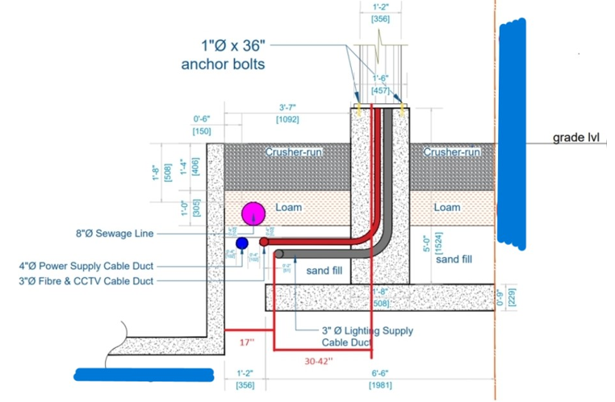
Figure 1: Light Pole Foundation to be Constructed.

Work Includes:

- Excavation of Soil
- Compaction of Soil
- Lay 2’’ (1:6) Cement-Sand Blinding.
- Bend Steel reinforcement with a minimum yield strength of 61,000 psi.
- Secure in place bolts and reinforcement.
- Build Formwork
- Dewatering if necessary
- Pour Concrete (C30/37) for construction of base and pedestal
- Remove formwork
- Backfilling and compacting of excavated area
- Cleaning and carting away of construction waste.
- Adhering to Guyana Shore Base Inc. Permit to work and QSSHE guidelines.

Instructions to Bidders

- Proposals are to be submitted along Valid Business Registration or equivalent, Valid GRA & NIS Compliance, Local Content Certificate.

- Proposal and documents must be submitted to the e-mail address below on or before January 23rd, 2023.

Email: tenders@gysbi.com

