Request for proposal
Electrical Design Consultancy services

Guyana Shore Base Inc. hereby invites interested companies to submit proposals for Electrical Design Consultancy.

Description of Works

General: Provision of Consultancy service for the design and construction of Electrical Networks for lighting and power supply for CCTV camera system at the Guyana Shore Base Inc. (GYSBI).

Lighting System

- Designing of Electrical Lighting and light control system to achieve 4.5fc at GYSBI Annex (plots 1,2,3 and4).
  - Lights Shall be mounted on 70’ Galvanized Steel poles
  - Operating Voltage 277/480 Volts
  - Lights Shall be of LED type
- Provision of detail Construction and As-Built drawings in CAD and PDF formats.
- Compilation of complete Bill of Quantities required for the installation and efficient operation of the system.
- Provision of consultancy service during construction and commissioning.

CCTV Camera Power supply Network

- Designing of Electrical Network to supply power for CCTV Cameras at GYSBI (plots 1,2,3 and4).
- Provision of detail Construction and As-Built drawings in CAD and PDF formats.
- Compilation of complete Bill of Quantities required for the system.
- Provision of consultancy service during construction and commissioning.

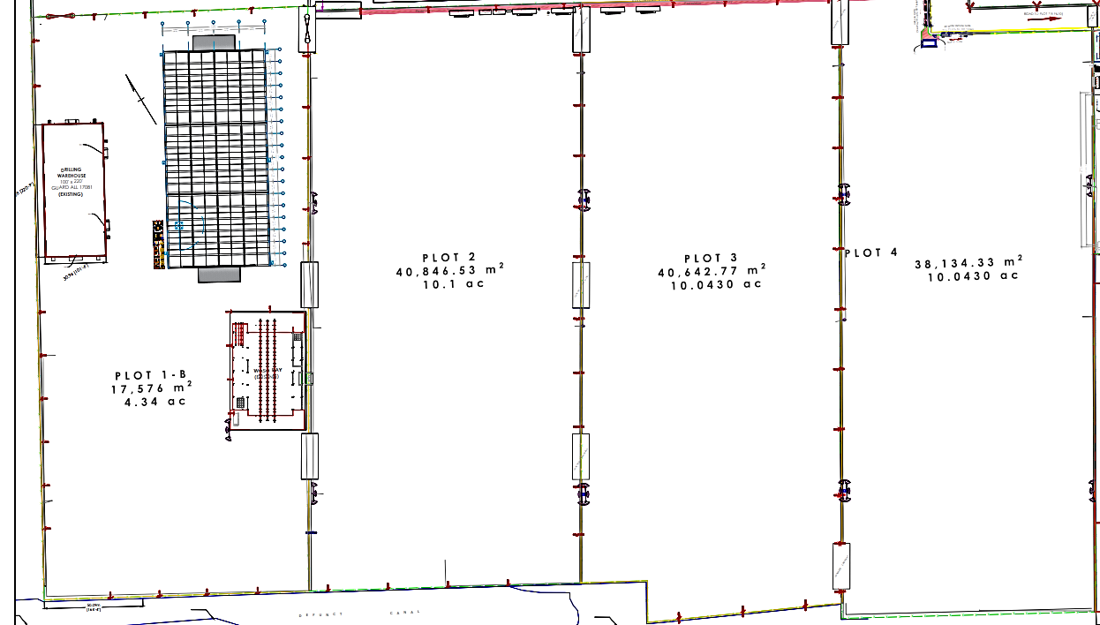

Figure1: Sketch of GYSBI Annex

Instructions to Bidders

- Proposals are to be submitted along Valid Business Registration or equivalent, Valid GRA & NIS Compliance, Local Content Certificate.
- Proposal and documents must be submitted to the e-mail address below on or before January 23rd, 2023.

Email: tenders@gysbi.com

