WASTEWATER MANAGEMENT SOLUTION

BACKGROUND

The Guyana Shorebase Incorporated (GYSBI) is a mixed facility providing various services to the Off-Shore Oil & Gas outfit, it comprises of office buildings, man-camps, and warehouses. The existing wastewater system (See Figure 1 attached) is inadequate and relies on third party contractors for wastewater management, primarily the removal of sewage in mobile tanks. An approximate population of 566 persons during the day and 215 persons during the night utilize the washroom facilities, however, given the continued expansion of GYSBI, it is anticipated that the present wastewater system will be overwhelmed. Therefore, the need to urgently acquire a more long-term sustainable solution for the management of its wastewater.

GYSBI hereby request for Expressions of Interest (EOI) to provide a Design-Build Wastewater/Sewage Management Solution (WWMS) which must meet all the EPA requirements.

GENERAL SPECIFICATIONS & EVALUATION

GYSBI expects the following would be considered in the eventual Wastewater Management Solution as a general guide:
- Basic and detailed engineering inclusive of all related civil, piping, mechanical, electrical instrumentation and automation design including any other miscellaneous work, accessories, etc. Providing a comprehensive “Operation and Maintenance Plan”.
- Procurement and supply of material, fabrication and assembly, shop testing, inspection, painting, marking, preservation/ protection, transportation, installation, pre-commissioning and commissioning.

“Contractors” submitting an EOI should demonstrate that adequate experience in Design-Build Solutions are possessed.

INSTRUCTION AND SUBMISSION OF EXPRESION OF INTEREST

Interested parties should understand that submissions need only to indicate interest. Once interest is expressed, Contractor will be provided with detailed Request for Proposal (RFP) in accordance with the FIDIC mechanism.

The following should be provided:
- Must submit valid Business Registration or equivalent, Valid GRA & NIS Compliance and Local Content Certificate.
- Submission of Expression of Interest and above-mentioned documents must be sent to the e-mail address below on or before December 22nd, 2022.

Email: tenders@gysbi.com

1 of 2

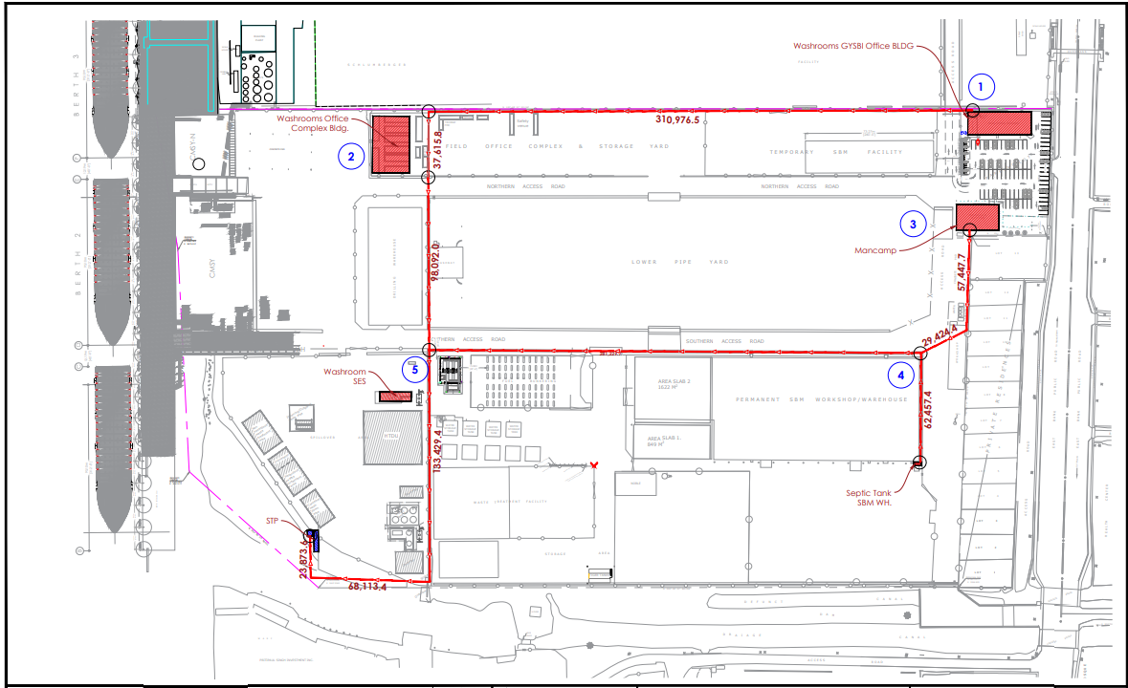

Figure 1: Existing Wastewater System – Septic Tank locations within GYSBI facility.

2 of 2

