Request for Quotation
Supply & delivery of Branded T-Shirts

Guyana Shore Base Inc. hereby invites interested bidders to submit quotations for the Supply & Delivery of Customised Branded T-Shirts as per the specifications below:

No. | Specifications | Qty
1 | Polo T-Shirts (S) | 100
2 | Polo T-Shirts (M) | 150
3 | Polo T-Shirts (L) | 150
4 | Polo T-Shirts (XL) | 150
5 | Polo T-shirts (2XL) | 50

Guyana Flag on Left Sleeve of T-Shirts and 2 Year LTI Free on the Left Chest.

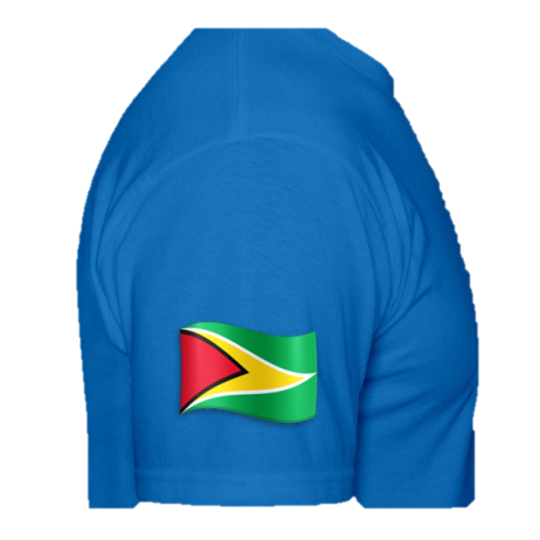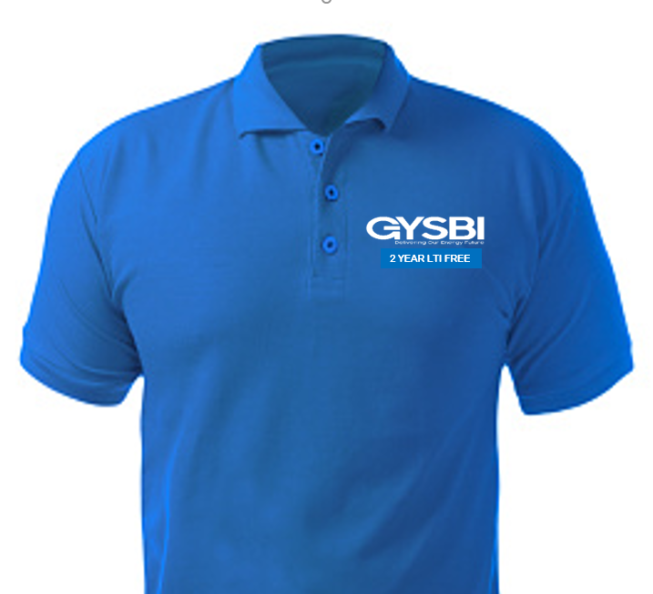
The brands preferred are: Under Armour, Nike, or Adidas.

Interested bidders are to submit the following to the e-mail address given below:

- COMPANY DETAILS
Company Name, Business Address, Website

- CONTACT DETAILS
Name, position, email, phone number

- COMPANY REGISTRATION
Valid Business Registration or equivalent, Valid GRA & NIS Certificates

Submission of quotation, inquiries, and request for images of the Yealink IP Phones can be done via the e-mail address below on or before October 7th, 2022.

E-mail: procurement@gysbi.com

