Supply and Delivery of CALDWELL A360-5-14/12 Jib Crane

Background Information

The Maintenance and Warehouse Facility building is 122’ in width x 258’ long, having 31,476 square feet shared between Maintenance, Warehouse and general/wellbeing facility area, with an eave height of 35 feet for the main structure. The facility will be clear span with no internal columns other than a single raw to hold a dividing wall between Fleet Shop Area and Fabrication Shop. As part of the Fleet Shop area, floor mounted Jib Crane will be included for lifting tasks such as handling machinery and parts.

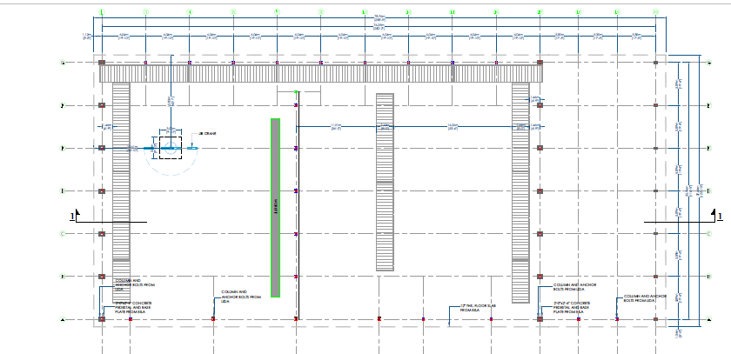

Figure 1: Featured location of the Jib Crane.

Specifications

Provider shall supply and deliver one (1) each 10,000 lbs. floor mounted CALDWELL A360-5-14/12 Freestanding Jib Crane and all components required for the installation at the featured location. The Jib Crane installation will be performed by GYSBI as well as the construction of the concrete foundation to receive the Jib Crane.
Additionally, the supplier will provide: CALDWELL MM-5-15B Hoist Package Manual Hoist manual Trolley PT050 Trolley-flange option B 7.03”-12” – CF050 Hoist w/15’ lift.

Hoist – Model MM
- Heavy Duty Design
- Upper & Lower Limit Switch
- Thermal Protected Fan Cooled Motor
- Bottom Swivel Hook with Safety Latch
- Chain Container
- Ergonomically Designed Push Button Station
- Top Hook Hoist for Easy Trolly Mounting
- Hand Chain with drop of 18” less than lift

Deliverables of the Crane

The successful provider will procure and supply a floor mounted Jib Crane with the following characteristics:
- Capacity: 10,000 lbs.
- Span: 12’-0’’
- Height under the boom: 14’-0’’
- Anchors pull force: 5960 lbs./bolt
- Approximately weight: 4,270 lbs.

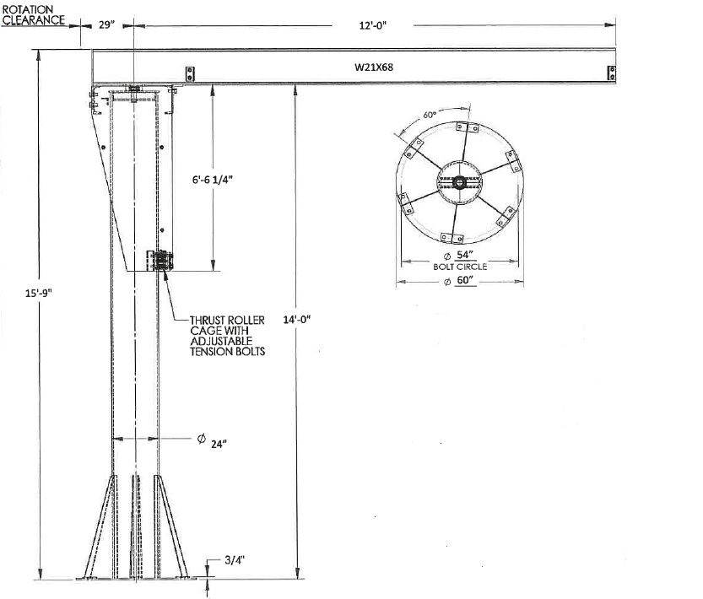
Figure 2: Jib Crane characteristics required.

Period of Delivery
JIB CRANE is expected to be delivered in no more than 3 months from the PO issuing date.

